

|  |  |  |  |  |  |  |  |  |
| --- | --- | --- | --- | --- | --- | --- | --- | --- |
|  | | | | | | | | |
|  | | Find Me Out | | | | |  | |
|  |  | | | | | | |  |
|  | | | |  |  | | | |
|  | | | | Jatin Kumar 21D100010 |  | | | |
|  | | | | **Date**July 31st 2023**Course title**Summer of Code**Mentor’s name** Nitsure Omkar |  | | | |
|  | | |  | | |  | | |



|  |  |  |  |  |  |  |  |  |
| --- | --- | --- | --- | --- | --- | --- | --- | --- |
|  |  | | |  |  | | |  |
|  | Brief Summary | | | | | | |  |
|  |  | | |  |  | | |  |
|  |  | |  | | |  | |  |
|  |  |  | The project “Find Me Out” aims to make a model which can perform face recognition for 4 separate persons. The model uses CNNs and achieves a high accuracy. The dataset for training consists of 300 images where 75 images belong to each person. A total of 100 images are used for testing the model, after it is trained.  Data Preprocessing has been a very crucial point and it has been performed very extensively. More about it ahead😊  The model performs really well with an accuracy of over 95%. | | |  |  |  |
|  | | | | |
|  |  |  |  |
|  |  |

|  |  |  |  |  |  |  |  |  |
| --- | --- | --- | --- | --- | --- | --- | --- | --- |
|  | |  |  | | |  |  | |
|  | | Introduction | | | | |  | |
|  | |  |  | | |  |  | |
|  | Face recognition has emerged as a fundamental application of computer vision, with a wide range of real-world applications such as biometric authentication, surveillance, and human-computer interaction. In this project, I have developed a robust and accurate face recognition model capable of multi-class classification.  The primary objective of the project was to create a model which is able to recognize the face of 4 celebrities and place it in an appropriate class.  As we all know that accuracy and success of any AI model, especially which uses unsupervised ML, greatly depends on the variety of data.  In my case the dataset of 300 images was frankly not good enough, so we use data-augmentation to effectively increase the size of dataset and make a robust model.  My model uses CNNs to achieve an accuracy of over 95%.  The model was not made overnight, it began with getting familiar with basics of python and slowly progressing to understand supervised ML, image processing, clustering, image segmentation before finally moving to unsupervised learning, neural network understanding and CNNs. Since I began from scratch, I will be explaining everything in a detailed manner.  In conclusion, this project showcases the development of an efficient and accurate face recognition model for multi-class classification. The model's versatility and potential for real-world applications hold significant promise for biometric security systems, facial recognition-enabled devices, and various other fields where accurate identification of individuals is crucial.  The journey of model training and evaluation has been very informative, resulting in deepening my understanding of deep learning and its practical applications. In the following sections, I present a detailed account of the methodologies, experimental results, and conclusions, offering valuable insights into the face recognition model we have built. | | | | | | |  |
|  | Useful Resources:  * Stanford Online YouTube channel * MIT Open Course Ware * Derek Banas * [www.geeksforgeeks.com](http://www.geeksforgeeks.com) | | |  | * ChatGpt (really helps in understanding of a question by virtual cross-questions) * [www.towardsdatascience.com](http://www.towardsdatascience.com) * wwwtensorlow.org | | |  |
|  |  | | |  |  | | |  |

|  |  |  |  |  |  |  |
| --- | --- | --- | --- | --- | --- | --- |
| NOTE | These resources came in very handy and helped me a lot in understanding what machine learning actually is and what can it potentially do. The motivated me to go even deeper in this field. Strongly recommended. | | | | |  |
|  | |  |  |  |  | |
|  |  | | | | |  |

# Data Collection and Preprocessing:

Now let us proceed to understand how we developed the model. The first step is data collection. As you are aware, the model aims to recognize the faces of 4 different persons and then classify them into 4 different classes ultimately telling us who the face belongs to.

In my project I have used the faces of following people:

* Donald Trump
* Robert Downey Jr.
* Will Smith
* Alia Bhatt

The reason for choosing popular faces was obviously to aid me in data collection. They have their faces all over the internet. Also, I discovered that Alia Bhatt has British citizenship. (Not relevant to the project, please ignore!)

So, what I did is I went to google and googled their names, then into images section which was full of their pictures. There I took 100 screenshots of images of each people and cropped them so that they only had faces of these people. I noticed cropping was very effective in determining the accuracy of the model.

This gave me a total of 400 faces where 100 faces belonged to each person. I uploaded all these images on my google drive in 8 different folders. Each face had 2 folders associated with it, the first one had 75 images meant for training the model and the other one had 25 images to test the trained the model. I uploaded on google drive because I was using Google Colab for coding.

Now since I had the required images, next step was to reading those images in google colab, this was done by cv2.

First thing was getting the path of folders which had the images of each person.

For this we just define the 8 different variables and the value of this variables is given by the path of those 8 respective folders. The following code snippet explains this:

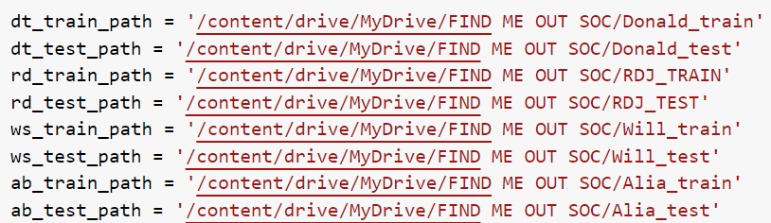

These variables were the paths of the folders and now let us read the contents of these folders into 8 different lists so that each person will have 2 lists associated with him/her containing 75 images (for training) and 25 images (for testing) respectively.

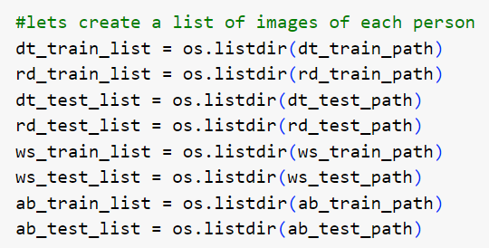

Now we have images for each person for both training and testing and if you think we are done with data, you are highly mistaken.

Computers understand the numbers, not images. In fact, that is why we are making the model, right?

Before we move on to reading the images of these folders as matrices, let us create labels for identifying each face. We will relate the image of each person to a specific digit. Here is what I used:

* 0(Zero) => Donald Trump
* 1(One) => Robert Downey Jr.
* 2(Two) => Will Smith
* 3(Three) => Alia Bhatt

Labels are created separately for training and testing. It consists of 2 list namely train_labels and test_labels.

* train_labels includes a total of 200 elements and equal number of 0,1,2 and 3.
* train_labels includes a total of 100 elements and equal number of 0,1,2 and 3.

After creating these lists, they are shuffled so that these labels are distributed randomly within the lists. Here is the code for train_labels :

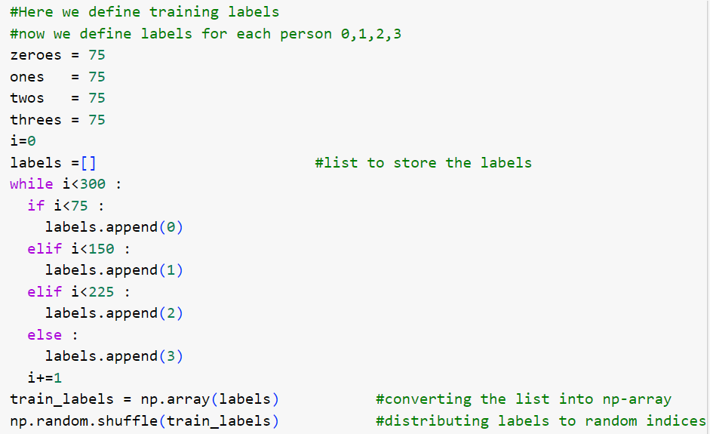

The labels for testing are generated in the similar way except they are 100 in total. I am not putting the code for that in here but it is very obvious.

Let us read the images now:

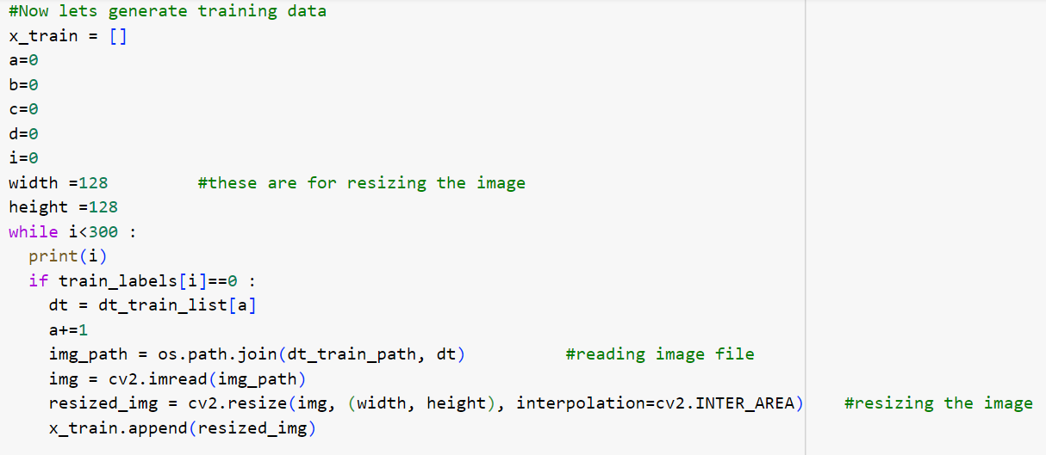

First we define a list to store the training data. As pre-processing will involve resizing the images to same value we define the width and height of image. It can be taken anything. Now you understand, why we shuffled the labels because it ensures that training data is distributed randomly.

If the label matches the require label, path is taken from the respective training list and we can obtained the path of the image by using os library which joins the path of the list with that particular image, ultimately giving the path of image. After getting the path of image, I used cv2 to read the image, resize it to required size and append the image into training data, giving us randomly distributed training sets. Similarly, test data can also be obtained.

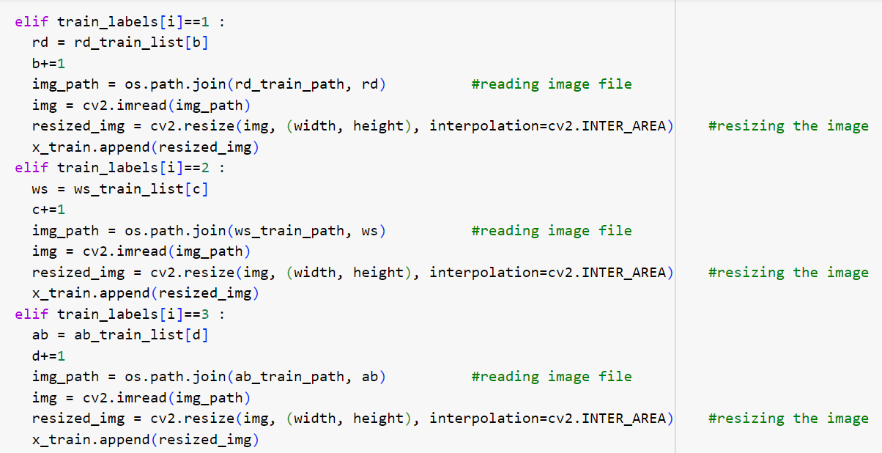

# Model Architecture:

Now that we have training data and test data. We convert the labels into one hot labels. The next step is to develop a model. I have already studied the concepts and working of deep neural networks where I performed binary classification using NumPy, etc. However, for developing the model, we will use TensorFlow. After watching TensorFlow tutorial videos, it was really a piece of cake.  
Here is the stepwise explanation of each line of code:

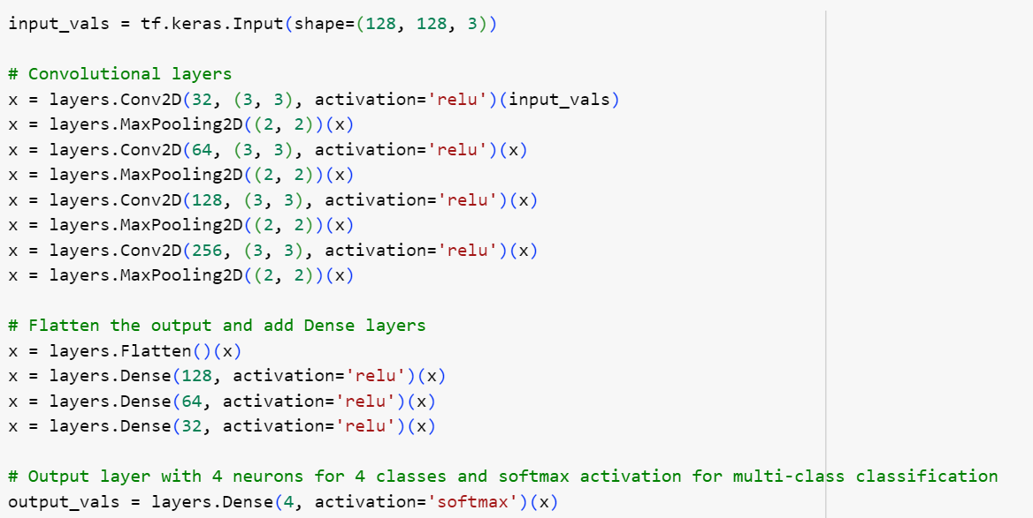

First input_vals is input which decides what size of input will be entering. X is a temporary layer which is a 2-D convolutional layer (which are extremely helpful in face recognition system) and 32 in first line represents the number of filters or kernels. It means that model will go through the layer for 32 times to detect a pattern or something. Then (3,3) represents each filter will have a window size of (3,3) to slide over input data in that layer. Activation is relu means that the output will be non-negative. And then input_vals is the output of previous layer. Then max-pooling layer is added which reduces the size of data. The max-pooling operation takes the maximum value within each 2x2 window and discards the rest, effectively reducing the size of the feature maps. X is the output of previous layer. Overall, this line of code adds a 2D max-pooling layer to the model, which helps in down sampling the spatial dimensions of the data, making the model more computationally efficient and reducing the risk of overfitting. Then this process is repeated again and again for 4 times executing 4 convolutional and 4 max-pooling layers.

Now we add dense layers to it which require 1-D arrays so we use “x.flatten” to flatten the 2-D array into 1-D. Then with activation relu and 128 neurons, wee move on to next layer. This is repeated 3 times with different number of neurons and finally we move onto output layer. This layer takes output of 3rd dense layer as input and produces an output using 4 neurons. It is important that number of neurons in last layer equals to number of classes the model will classify the data into and we use SoftMax activation in last layer because we need output in terms of probability and SoftMax does that.

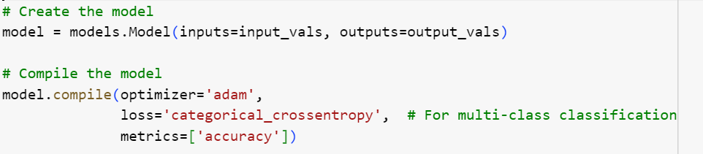

Now we make a model which uses the previous layers into it.

We compile the model with Adam optimizer which is a very popular and adaptive optimizer, this takes care of setting up a decent learning rate. It adapts the learning rate for each parameter based on the past gradients, which allows it to handle sparse gradients and noisy data efficiently. It also incorporates momentum to accelerate the learning process in the right direction.

Loss is defined as categorical-cross entropy which is suitable for multi class classification.

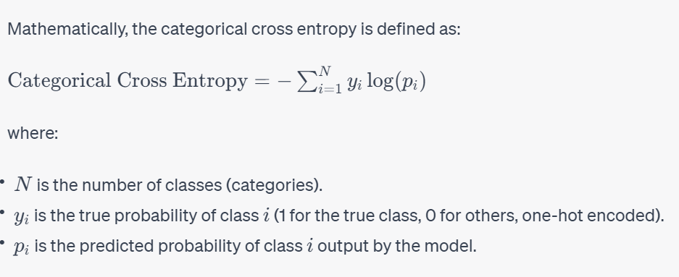

Accuracy, as the name suggests, used the metric which measures how many cases were predicted right. By compiling the model with we add parameters to the structural part created above with different sets of layers. This image gives a rough idea how the model is supposed to work.

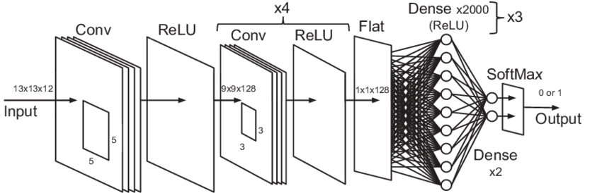

# Training and Evaluation:

Now since the model is ready, we have to train it for our data, but before that since the data is not too large, we perform data augmentation to effectively increase the size of data.

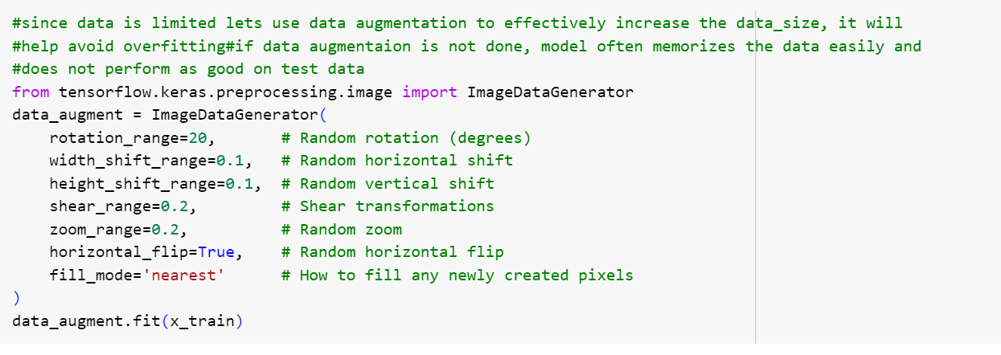

As the name suggests each command randomly applies following functions in given range so each time the model gets a little bit different data every time, this was really effective to avoid overfitting.

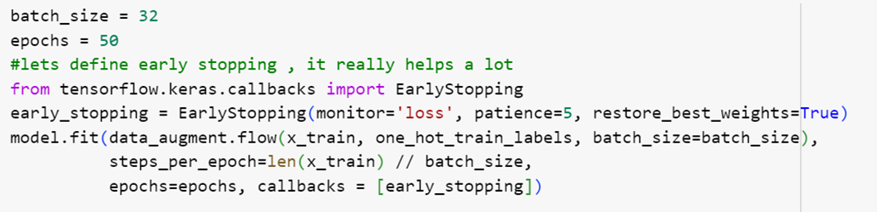

Now for training the data, we simply use model.fit operation, data_augment allows augmentation of data, which we did previously.

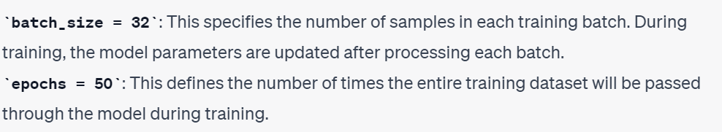

We also use early stopping with a patience of 5 which means the model will stop iterating if it is not improving for 5 consecutive iterations and model retains the best values of weights.

This will give us the trained model. Next step is evaluating the model. This is very easy to understand it from the given code



After testing the data and getting suitable accuracy we move to saving the model which is handled by following code:

model.save('/content/drive/MyDrive/FIND ME OUT SOC/SOC_2023_jatin_face_detection_model')

The model is ready!!!!!!

# Results:

* The model had an accuracy of over 95%. This achievement is remarkable, considering the limited size of the dataset and the complex task of identifying multiple individuals.
* Early stopping implementation helped terminating the training in 34 epochs
* Accuracy went as high as 96% in training cases.
* Performance on single image test cases:

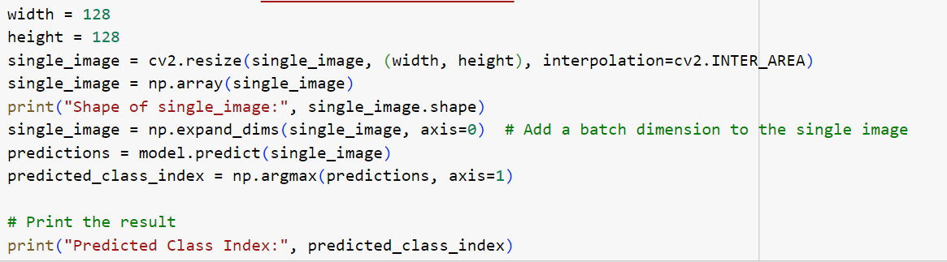

I tested it for 10 different images and it performed excellent identifying all of them correctly. So, it is safe to say that project ne Macha diya.

Also, this accuracy if not good was used to tune the hyper-parameters like number of layers, neurons, filters and optimizer. Throughout this project, we delved into the world of deep learning and gained valuable insights into its practical applications. As we move forward, we aim to explore more advanced techniques and contribute to the advancement of face recognition technology, enhancing security and user experiences in various domains.

Overall, this project has been a fulfilling journey, and we look forward to further exploration and innovation in the field of face recognition.

I would like to mention that before making this project, I performed binary classification for a different dataset, which really helped me understand the basics of TensorFlow and its application. Once you understand the commands and logics it’s is not that tough.

Signing off…

Jatin Kumar

# Future work:

Since the model is now capable of face recognition, there are several sectors to expand the project:

* Age and gender prediction using webcam
* Emotion prediction using webcam
* Face lock in phones
* Combining face recognition along with biometric and voice recognition to increase its utility for security purposes
* Combining the model with appropriate hardware to make a bot capable of understanding human facial expressions